Food Therapy
Category | Meat & Dairy | Vegetables & Fruits | Grains/  Beans/  Others
Warm/  Hot  Foods | Beef, Chicken, Chicken egg yolk, Chicken Liver, Goat Milk, Ham, Lamb Kidney, Lamb Liver, Lobster, Mutton, Pheasant, Prawn, Shrimp, Venison | Apricot, Blackberry, Cherry, Chestnut, Citrus, Clove, Coconut, Coriander, Fennel, Ginger, Garlic, Horseradish, Mustard, Nutmeg, Papaya, Peach, Pepper, Plum, Pumpkin, Quinoa, Raspberry, Rosemary, Squash, Sweet Potato, Sunflower Seed, Tangerine, Thyme, Turmeric, Walnut | Brown Sugar, White Rice, Malt Sugar, Oats, Olive Oil, Rice Vinegar
Cool/ Cold  Foods | Alligator, Clam or Mussel, Cod, Duck, Duck Egg, Egg White, Frog, Herring, Oyster, Rabbit, Scallop, Shark, Turkey, White Fish, Yogurt | Alfalfa, Apple, Amaranth, Banana, Bitter Melon, Blueberry, Broccoli, Celery, Cucumber, Eggplant, Seaweed, Kiwi, Mango, Mushroom, Orange, Pear, Persimmon, Spinach, Strawberry, Tomato, Watermelon, White Radish | Barley, Brown Rice, Flax Seed Oil, Honey, Sesame Seed, Sesame Oil, Salt, Tofu, Wheat Flour
Neutral Foods | Beef, Beef Liver, Bison, Catfish, Chicken Egg, Carp, Eel, Goose, Milk, Pork, Pork Kidney, Pork Liver, Quail, Salmon, Sardines, Squid, Tripe, Trout, Tuna, Wild Rabbit | Cabbage, Carrots, Cauliflower, Date, Figs, Lemon, Sweet Potato, Yam | Black Bean, Corn, Green Beans, Green Peas, Kidney Beans, Peanuts, Red Beans, Soy Bean, String Bean, White Sugar

Diet Plan
Condition - __________________________________________
Form - ______________________________________________
Protein - ____________________________________________

**Chart by Chi University’s TCVM Food Therapy**

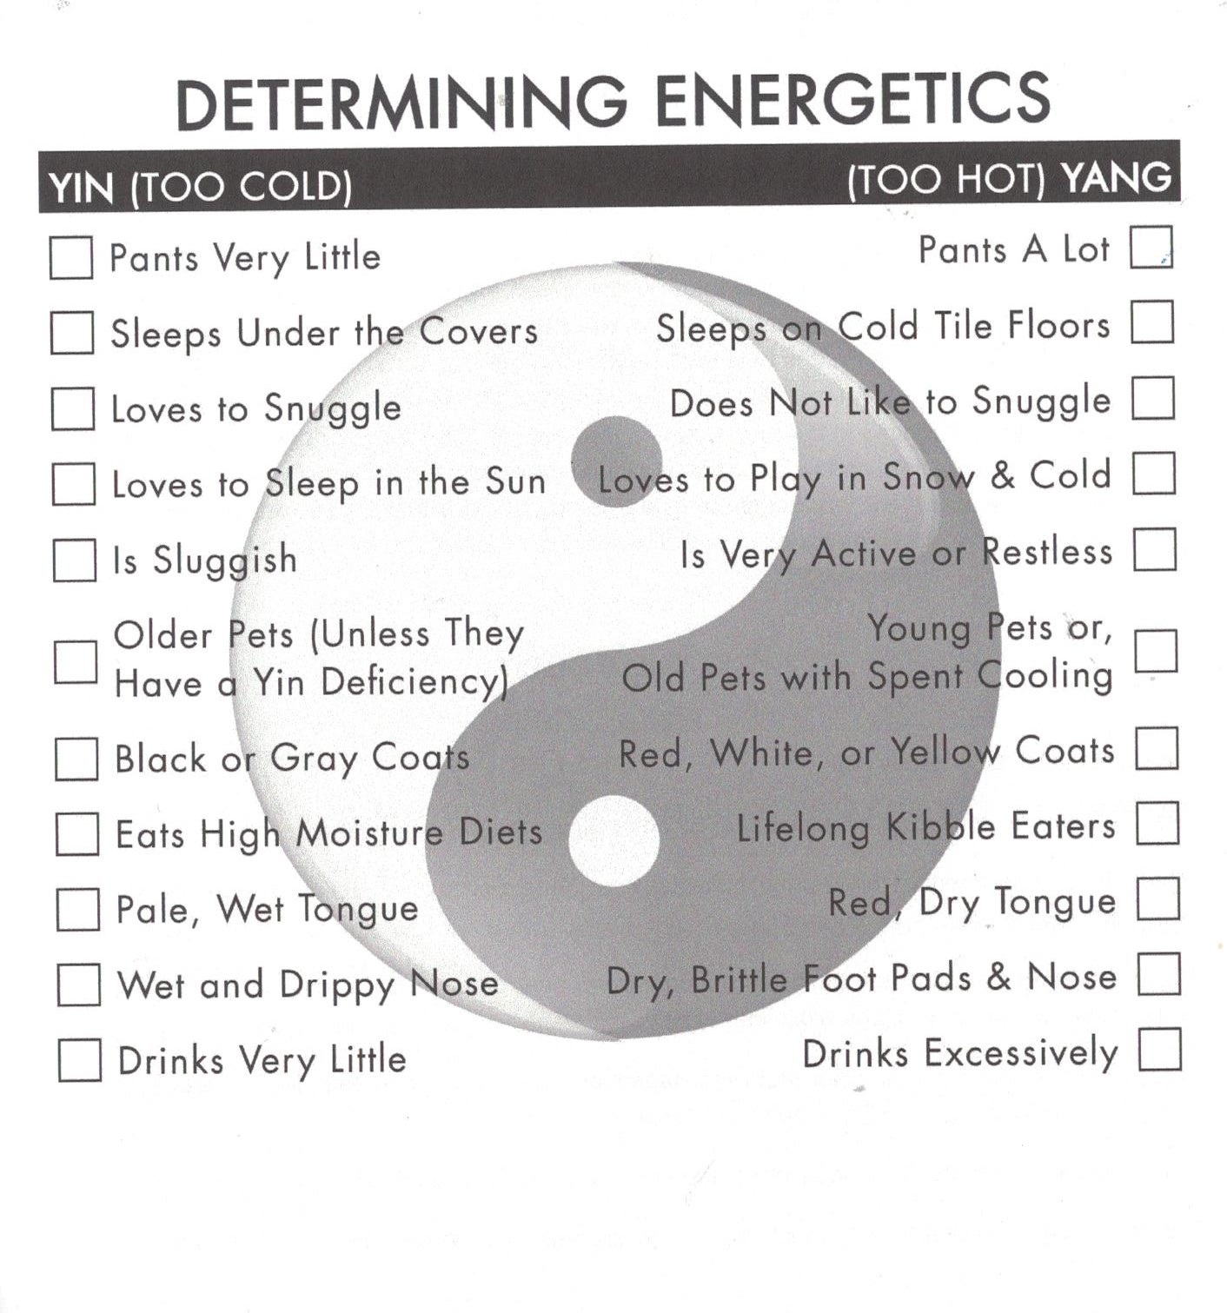
**Chart from Yin & Yang Nutrition for dogs**

