Healthy Eating
What we put in the food bowl is the most important health decision we will make for our pets
Eating healthy is not easy, but the more we do it the better off we are. Feeding/eating as much non processed food as possible is the goal.

- Crock Pot, Human/Table food
  - add enzymes and Probiotic
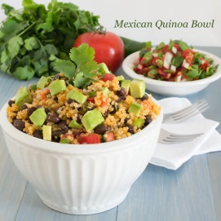
- Dehydrated Raw
Freeze Dried Raw
Frozen Raw

- Raw Diet
  - Add enzymes and probiotic
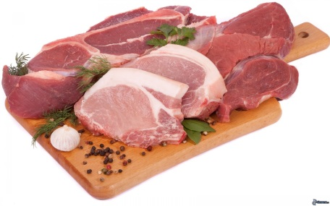

- High quality Kibble-reduce amount 25-50%
  - add 25-50% Fresh raw/cooked ingredients (meat and vegetables)
  - also add some organ meats (heart,liver,kidney) now and then

***Multiple enzyme probiotic products
- Flora4
- Missing Link
- Standard Process

